**Day 3 : 8 Sep 2024**

**Express JS End point**

**Ie Get, Post, Put/patch and Delete**

**Get -🡪 Get the resources like employee, customer, order, product etc.**

1. **Get all records**
2. **Get specific record using id with help of query param or path param**
3. **Query param**

**url?key=value passing single value**

**url?key=value&key=value passing multiple value**

1. **Path param**

**url/value passing single value**

**url/value1/value2 passing multiple value**

**Select query with where clause**

**Post -🡪 Create the resource like employee, customer, order, product etc**

**-🡪 insert query**

**Put/ Patch -🡪 Update the existing resource using unique property like update employee information using eid, update product details using pid etc.**

* **Update query**

**Patch is use to update partial object and put is use to update whole object using unique property ie pk**

**Product**

**Pid, pame, price**

**Patch -🡪 update product price or pname using pid**

**Put 🡪 update pname and price using pid.**

**Delete 🡪 delete method is use to delete the resource using some property generally id. Receive the id using path param etc**

**Delete query with where clause.**

Creating express js project responsible to provide product end point connect the array.

Create a folder express-product-api

mkdir express-product-api

cd express-product-api

npm init this command is use to create package.json file

then we need to install required module

like npm install express

npm install this command is use to download all module in current directly with help of package.json file

Verify the PostGres SQL Database in VM

C:\Program Files\PostgreSQL\16\bin

psql -U postgres

password : provide your password

\list to check all database present in your account.

create database testdb; it is use to create the database.

\c testdb; it is use to switch inside testdb database.

create table product(pid int primary key,pname varchar(50), price float);

insert into product values(1,'TV',67000);

insert into product values(2,'Computer',45000);

select * from product;

mkdir express-product-restapi-with-postgres

cd express-product-restapi-with-postgres

npm init or npm init -y

npm install express pg

pg -🡪 for post gres database

mysql 🡪 for mysql database

mongodb-🡪 mongo db database.

pg is one the external third party module which provide set of api which hep to connect postgres sql database using node js

user defined modules : user defined module is like a package. Using user defined module we can break our code in more than one file to do re-usability or maintainability. Those file can more contains more than one variable, function, classes which have same name but different purpose.

These files we connect using export and import (ES6 features) or require (ES5 features).

mkdir user-defined-modules

cd user-defined-modules

Creating express js application using MVC style

config --🡪Folder 🡪dbConfig.js which contains database connection details.

repository -🡪Folder (contains more than one file which contains database related code). 🡪ProductRepository, OrderRepository, AccountRepository, LogingRepository etc.

these file import or load dbConfig file and get the reference of Pool and do the operation on table etc.

controller -🡪 folder (it is responsible to receive the value from routing file). Base on controller method it call respective repository method and return result to router file. Controller contains request and response object. ProductController, OrderController, AccountController, LoginController

router -🡪 folder , this file routing the request base upon http method and sub path and it pass the request to controller method. router.js (generic file), productRouter.js, orderRouter.js etc.

app.js or main.js

this file responsible to load required module like express or middleware module like cors etc

then provide the main path for the application and redirect the request to router file base upon the main path.

It provide listener details ie port number and host name.

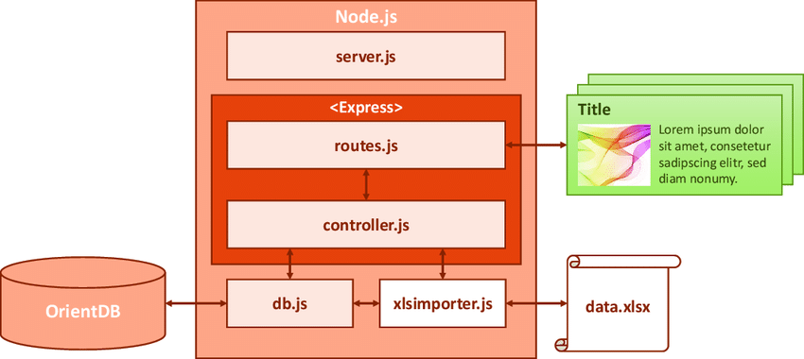

mkdir express-mvc-postgres-pg

cd express-mvc-postgres-pg

npm init -y

npm install express pg